**Media advertising performance optimization (November 2023- April 2024)**

**Problem Statement**

**Clay Art communication** is a media advertising company in Nigeria that focuses on creating campaigns that add value to people's lives and resonate with consumer. The marketing operation came up with **media ads optimization** project **to address inefficient performance and increased cost across platforms** through a **media campaign**. The project is geared towards investigating the right platform that will generate long-term profitability and competitive positioning in the digital marketplace.

The project focuses on important key performance indicators (KPIs) such as Impression, Clicks, Conversion, Revenue, Cost and profit across platforms.

This project will help identify platform/s that would generate high conversion rate with less revenue and vice versa. It will help examine how different platform perform and how budget should be utilized efficiently.

**Project Questions**

The main objective of this analysis is to identify the key questions, such as;

* Which platform contribute the most in terms of volume and value from November 2023 to April 2024?
* Which platform delivered the highest return on investment and conversion efficiency?

**Data Structure**

This Dataset contains important metrics such as impression, clicks and conversion rates from November 2023 to April 2024.

* **Factmedia**: This is the main fact table that contains media advertising rates of impressions, clicks, conversion, revenue, cost and profit. It also contains location rows that represent names of regions and countries.

Metrics calculated for the table are; conversion rates(Total clicks /Total conversion),Conversion efficiency(Total conversion/Total cost), Click-through rate(Total click/Total impression,0),cost per click(Total cost/Total clicks) and revenue per click(Total revenue/Total clicks).

* **DimDate**: The table contains column with day, weeks, months, month year and year.

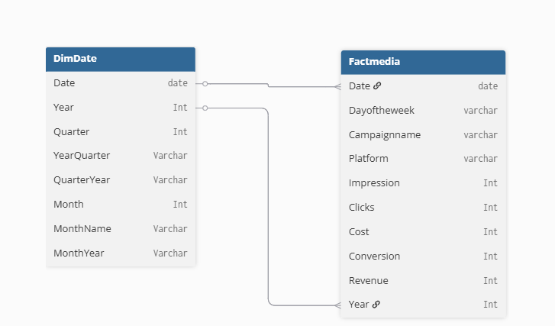

**Technical Details**

This project used Power BI for all stages of data cleaning and analysis, with a focus to address inefficient performanceacross media campaign from November 2023 to April 2024.

**Skills & Function Used**

**Skills:** Format, Calculate,Aggregate Function(Sum, Divide, AVERAGEX)

**Steps Overview:**

**Initial Inspection:** Checked all source tables (DimDate, Factmedia) for missing values, duplicate entries and inconsistent data types.

**Cleaning & Standardization:** Converted Types.

**Calculated Metrics:** Conversion Rate, Conversion efficiency, Profit margin, Click-through rate, Cost per click and Revenue per click.

**Data Cleaning Actions**

Here are the key cleaning operation;

* **Converted Types**

Purpose: Converted the cost row data type from whole number to decimal number for accurate analysis.

**Date Table** **Details**

The date was inserted into this StartDate and the last day was inserted as the EndDate and this helped to create a date table which contains day, weeks, month, month year, Quarter year, year.

**Steps Details**

The date table was created through this method;

let

// Create parameter

StartDate = List.Min(FACT_MEDIA[Date]),

EndDate = #date(2024,4,30),

Step = Duration.Days(EndDate - StartDate)+1,

// Create the List of date

Source = List.Dates(StartDate,Step, #duration(1,0,0,0)),

#"Converted to Table" = Table.FromList(Source, Splitter.SplitByNothing(), null, null, ExtraValues.Error),

#"Changed Type" = Table.TransformColumnTypes(#"Converted to Table",{{"Column1", type date}}),

#"Renamed Columns" = Table.RenameColumns(#"Changed Type",{{"Column1", "Date"}}),

// Create additional columns

#"Inserted Year" = Table.AddColumn(#"Renamed Columns", "Year", each Date.Year([Date]), Int64.Type),

#"Inserted Quarter" = Table.AddColumn(#"Inserted Year", "Quarter", each Date.QuarterOfYear([Date]), Int64.Type),

#"Inserted Merged Column" = Table.AddColumn(#"Inserted Quarter", "Year quarter", each Text.Combine({Text.From([Year], "en-US"), "/Q", Text.From([Quarter], "en-US")}), type text),

#"Inserted Quarter Year" = Table.AddColumn(#"Inserted Merged Column", "Quarter Year", each Text.Combine({"Q", Text.From([Quarter], "en-US"), " ", Text.From([Year], "en-US")}), type text),

#"Inserted Month" = Table.AddColumn(#"Inserted Quarter Year", "Month", each Date.Month([Date]), Int64.Type),

#"Inserted Month Name" = Table.AddColumn(#"Inserted Month", "Month Name", each Text.Start(Date.MonthName([Date]),3), type text),

#"Inserted Month Year" = Table.AddColumn(#"Inserted Month Name", "Month Year", each Text.Combine({[Month Name], " ", Text.From([Year], "en-US")}), type text)

in

#"Inserted Month Year"

**Executive Summary**

With a total revenue of $552M generated across the six major platforms in 6months, the media campaign team identified performance inefficiency and increased cost issues that threaten sustainable profitability. The operation team witnessed an increase in expenses compared to 15.75% revenue growth which indicates extra cost that requires intervention and platform performance which requires strategic budget distribution.

**Instagram** generated the highest revenue with **$148.8M** but delivered a low profit margins of **59.16%** while **Twitter** achieves highest margins by **72.71%** with lower volume. Conversion rates did good across all platforms but **Twitter** and **Facebook** demonstrated the highest conversion efficiency with a conversion rate of **802.0%** and **787.5%** respectively.

The media campaign team needs to strengthen market presence from top performing countries to the less performed countries in other to boost sales through strategic marketing and promotions.

**Key Insights**

The analysis reveals notable successes and opportunities across various platform;

* **Based on volume:** **Facebook** and **Instagram** platforms contributed the most in terms of volume. **Instagram** led with **153.3M impressions**, followed by **Facebook** with **95.6M impressions**. In terms of conversions, **Instagram** led the way with **4.2M conversions**, followed by **Facebook** with **3.6M conversions**.
* **Based on value:** **Instagram** and **Facebook** were the top-contributing platforms. **Instagram** generated the most revenue at **$148.7M** and the highest profit at **$88M**. **Facebook** followed with **$126.9M** in revenue and **$86.7M** in profit.

Though, **Google Ads** and **LinkedIn** also performed well, with profits of **$75.4M** and **$45.9M**, respectively. **Twitter** and **Website** had the lowest profit margins and overall profit, with **Website** generating the least profit at **$12.9M**.

* **Return on Investment (ROI):** **Twitter** platform delivered the highest profit margin, a key indicator of ROI, at **72.71%**. **Google Ads** and **Facebook** also showed strong performance with profit margins of **66.11%** and **68.30%** respectively. **Twitter** and **Facebook** demonstrated the highest conversion efficiency, both with a conversion rate of **802.0%** and **787.5%** respectively. **Facebook** also had a strong click-through rate of **30.01%**.

**Recommendation**

Based on this analysis, here are my recommendations;

* **Which platform contribute the most in terms of volume and value through November 2023- April 2024**?

Given the high revenue and profit from **Facebook** and **Instagram**, Continue to invest in them as they are the primary drivers of financial results and consider allocating more resources to these platforms to maximize return of investment.

* **Which platform delivered the highest return on investment and conversion efficiency** ?

Consider increasing the budget for **Twitter** and expanding campaigns to capitalize on its high return on investment.